**Project Summary**

This dashboard  analyzes the performance of fast-food restaurant Blazin’ Burger located in various locations in New York. The various visulaizations in this dash board are as follows:

**Revenue Trends:**

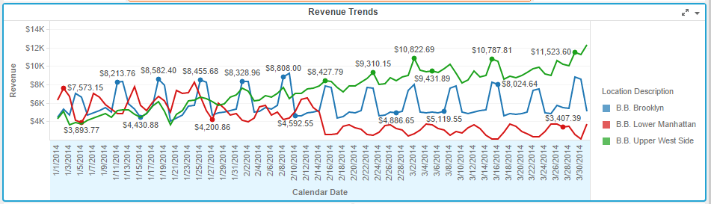

From the revenue trends figure we can observe that the revenue for all three locations was very similar until the middle of February. After that the revenue is gradually increasing for the B.B Upper West Side region, and constant for the B. B. Brooklyn region, and gradually decreasing for the B. B. Lower Manhattan region.

**Avg. Revenue vs Order Count By Day of Week:**

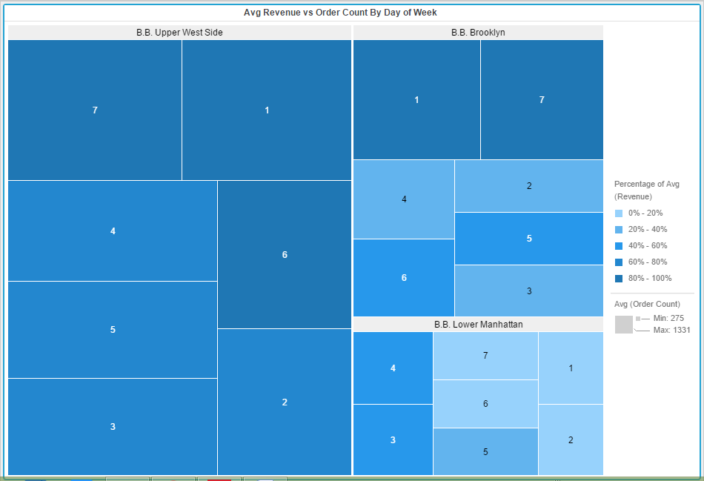

The heat map allows us to compare average order counts and revenue across all three locations for specific days of the week. In the map the size of each block indicates the Avg. Order Count for that day in a specific location and the color of each box indicates the Avg. revenue. Here the numbers 1,2..7 indicates the week numbers( 1 for Sunday, 2 for Monday….7 for Saturday). For Example all the dark blue colored blocks (7,1,6 in B. B. Upper West Side) have highest avg. revenue. It implies that the B. B. Upper West Side region has more revenue on Fridays, Saturdays and Sundays. Similarly we can identify the performance of various regions in week days.

The B. B Lower Manhattan region has very less orders when compared to other regions. The Avg. revenue is also very less on 1,2,7,6 week days.

**Order and Item Count Correlation:**

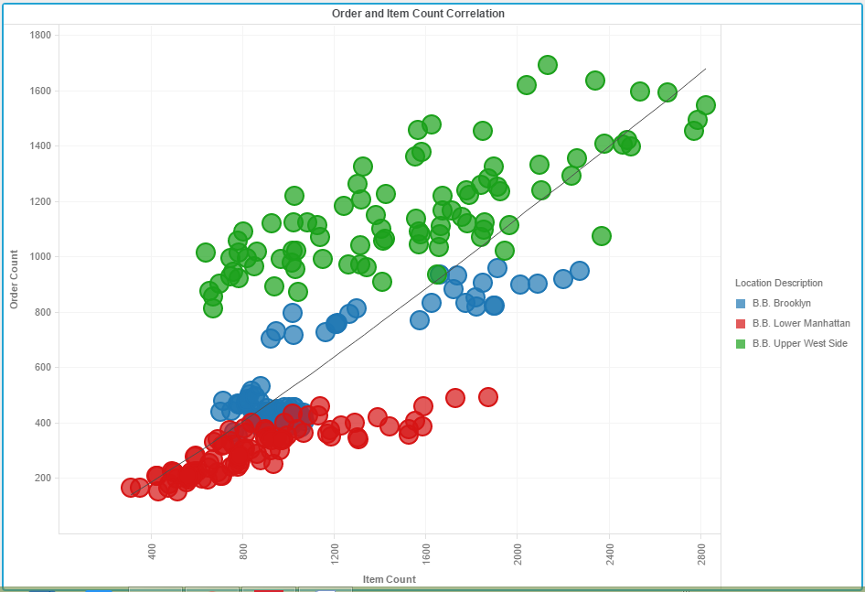

The above visualization shows the order and Item count correlation for the three regions and for each week day.

**Average Scores by Zip Code:**

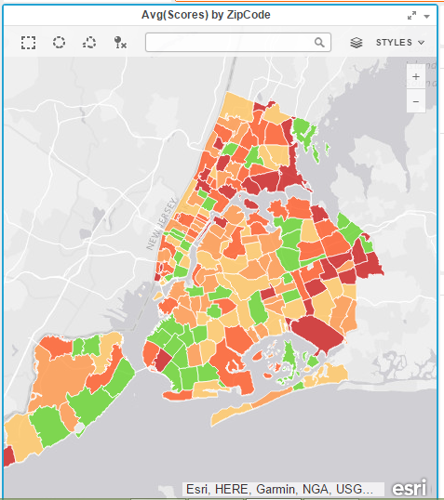

The map shows the zip codes of New York colored by the average health inspection score of the restaurants in that area. The lower the score, the better the grade. The lower numbers are green and higher numbers are red.

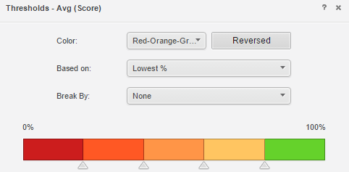

The threshold indicates that the highest scored regions are green (have lowest grade) in color whereas the lowest scored regions are red (have highest grade) in color.

**Revenue Performance vs Avg. Heath Score:**

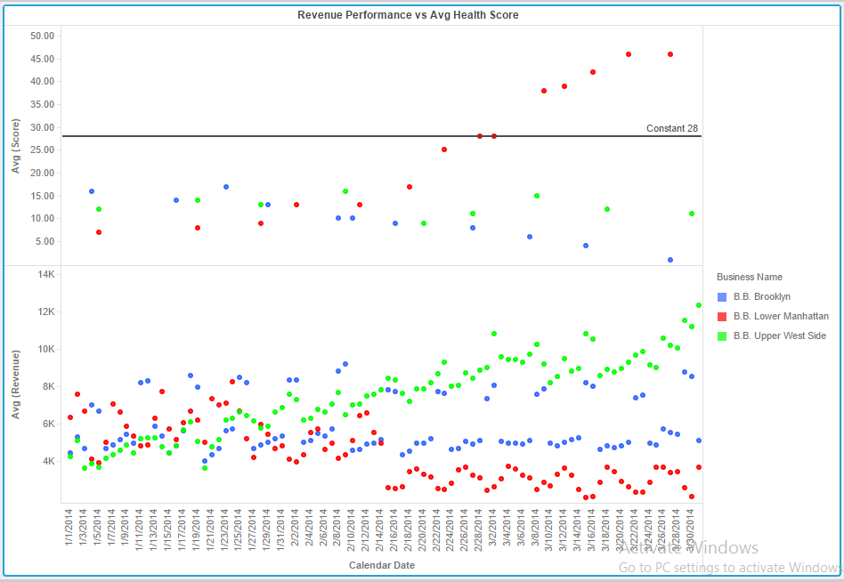

The graph shows how health inspection results (score) affected the revenue performance of each restaurant location. Any health inspection score above the reference line receives a C grade. From the figure it is clear that the health inspection score heavily impacts revenue performance for the restaurant location. Several conclusions that can be drawn from this figure are:

The health inspection score for the B. B. Lower Manhattan region is gradually increasing (indicates a lowest grade) from the middle of February. So the revenue performance for that region is gradually decreasing from the middle of February.

The heath inspection score for the B. B. Upper West Region is less( indicates a highest grade). So the performance of that region is gradually decreasing.

**Average Scores by Boro:**

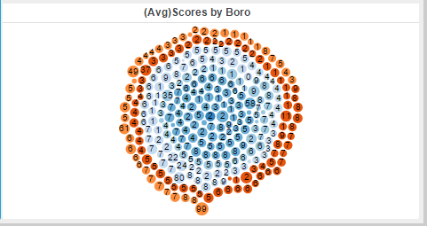

The bubble chart show scores based on Cuisine Type and by Boro. We can identify that the cuisine type code 27 has good fare across multiple boro’s .

**Conclusion:**

We could have analyzed why various regions are receiving less inspection scores and the violation codes. By identifying the reasons for less inspection score the performance in various regions can be improved. We could have analyzed which food items are famous in various regions.